# Accessing etext on an iPad

Students often use an iPad to access electronic text (etext). There are many ways to do this, depending on how you are accessing the file and what kind of file it is. Most of these will involve using the Share button, the Files App, or both.

## Share button Share button

The Share button is usually found in the top right-hand corner of the screen on the iPad. It allows you to move a document from where it is to somewhere else. The Share button opens up a menu with a list of apps that go from left to right, and below this there's a list of possible actions. You can pick one of the listed Apps to open the file in, or choose an action like "Save to Files".

## Files App Icon Files App

The Files app enables you to view all the files that are saved on your iPad. Each file type can behave slightly differently when you open them through the Files App.

* docx files will automatically open in the Pages App
* ePubs will automatically open in the Books App
* pdf files will automatically open in a viewer within the Files App. You can choose to open them elsewhere using the "Open in …" option, or choosing the Share button in the top right-hand corner of the browser window

When you choose to download a file, it will appear in the Downloads Folder 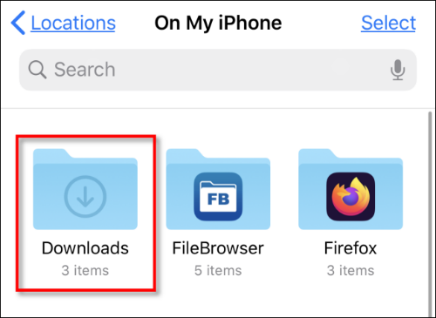within the Files App. You can order files in the Downloads folder alphabetically, or by date of download.

## Files from websites

### docx

* Tap on the file hyperlink. You will be asked whether you want to View or Download the document. Tap Download.
* Go to the Files App, choose the Downloads folder and choose the file to open.

### ePub

* Tap on the file hyperlink. You will be asked whether you want to Download the document. Tap Download.
* Go to the Files App, choose the Downloads folder and choose the file to open.

### pdf

* Tap on the file hyperlink. This will automatically open the pdf in the browser window.
* To download the pdf, tap the share button and choose whether to open it straight into an app, or to "Save to Files".

## Files attached to email from the Mail App

### docx

* Tap on the file. The file will open within the Mail App. In the top right hand corner, you can tap "Open in Pages" or the Share button.

### ePub

* Tap on the file. A menu will open up with a list of apps up the top where you could open the ePub, or and can tap "Save to Files".
* To open the ePub straight away, tap on the "Books" App and it will open.
* If you're opening multiple files at once, tap "Save to Files" and then choose the folder where the file should be saved.

### pdf

* pdf documents will often appear at the bottom of an email, in full.
* To open the pdf, tap on it from within the email.
* In the top right-hand corner, you can choose to "Open in Acrobat" or tap the Share button.

## Files from GoogleDrive

### docx

* Tap on the link to the file. It will open in Google Docs.
* To download the file, tap "File 🡪 Download" and then choose the file type. A pop up window will come up, tap "Download".
* Go to the Files App, choose the Downloads folder and choose the file to open.

### ePub

* Tap on the link to the file.
* It will open a new tab in the browser, with an option to "Download". Another tab will open, again choose "Download".
* Go to the Files App, choose the Downloads folder and choose the file to open.

### pdf

* Tap on the link to the file.
* It will open in Google Drive.
* To download the file, tap the download symbol Google Download Icon in the top right-hand corner of the screen. This will open the pdf within the browser.
* To download the pdf, tap the Share button and choose the preferred option.

SVRC, August 2022