Increasing the size of print music using MuseScore
MuseScore is a free, open-source music notation software and online repository of scores created by users. You can download the software from the MuseScore website, click on 'Download MuseScore without Muse Hub'.
Convert your PDF files on the MuseScore website. You will need to log in to do this, you can do this using Google and @education credentials. Once converted, the file will open in the MuseScore program as an editable score. The better the quality of the PDF, the better the conversion will be. Give the score a proof using the features within the program, much of which can be done through keyboard shortcuts.
Once the score is ready to go, there are several options to change how it is presented. Go to Format and then try the following. You can save a style through the Format menu, so if you find one that works, keep it for next time!
In Page settings
- Increase the stave space (sp) to scale up the music.
- Turn off 'Two-sided'. Lower the odd page margins to fit more music on the page.
- Change the orientation between portrait and landscape.
- Make the page size smaller
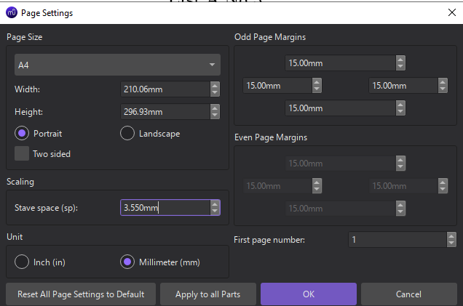
In Style Page
- Disable vertical justification of staves, then change the Maximum system distance to a lower number to move the staves closer together. Lower the minimum and the maximum to make the spacing even smaller.
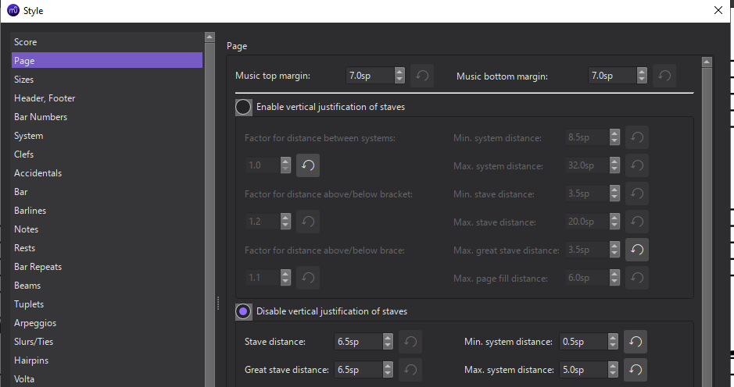
You can now export the file as a PDF for the student to view on their own device or print off a paper copy.
SVRC, June 2023

