Polaris Gmail Setup Enabling Less Secure Apps

Enabling Less Secure Apps in Gmail account
For the Polaris to have access to the Gmail account security setting in the Gmail account need to be changed to allow less secure apps. This can be done on a PC, iPad or Phone by going into the web version of Gmail.
- Go to your profile in Gmail on your computer or tablet/phone
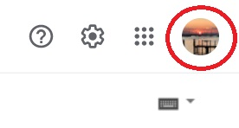
- Select Manage your Google Account
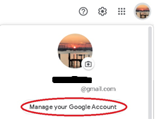

- Select Security from the left hand side bar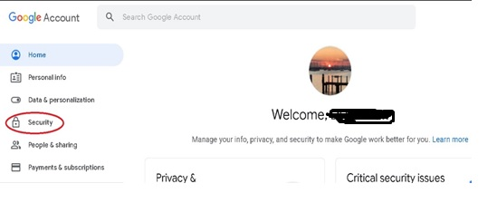
- Scroll to the bottom and turn on Less secure app access by sliding the bar to the right.
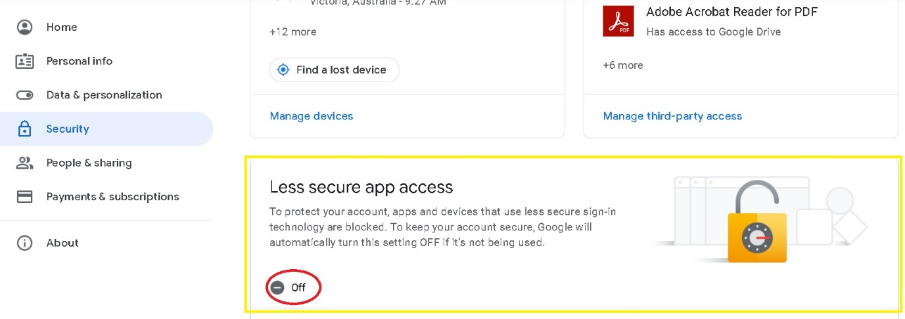

SVRC SSP Staff (November 2021)

