Index Basic V5 Windows Driver Installation
Looking at the back of the embosser the connections from left to right are for power, Wi-Fi antenna, USB type B (for connecting to a computer), Ethernet and USB type A (for connecting a USB thumb drive).
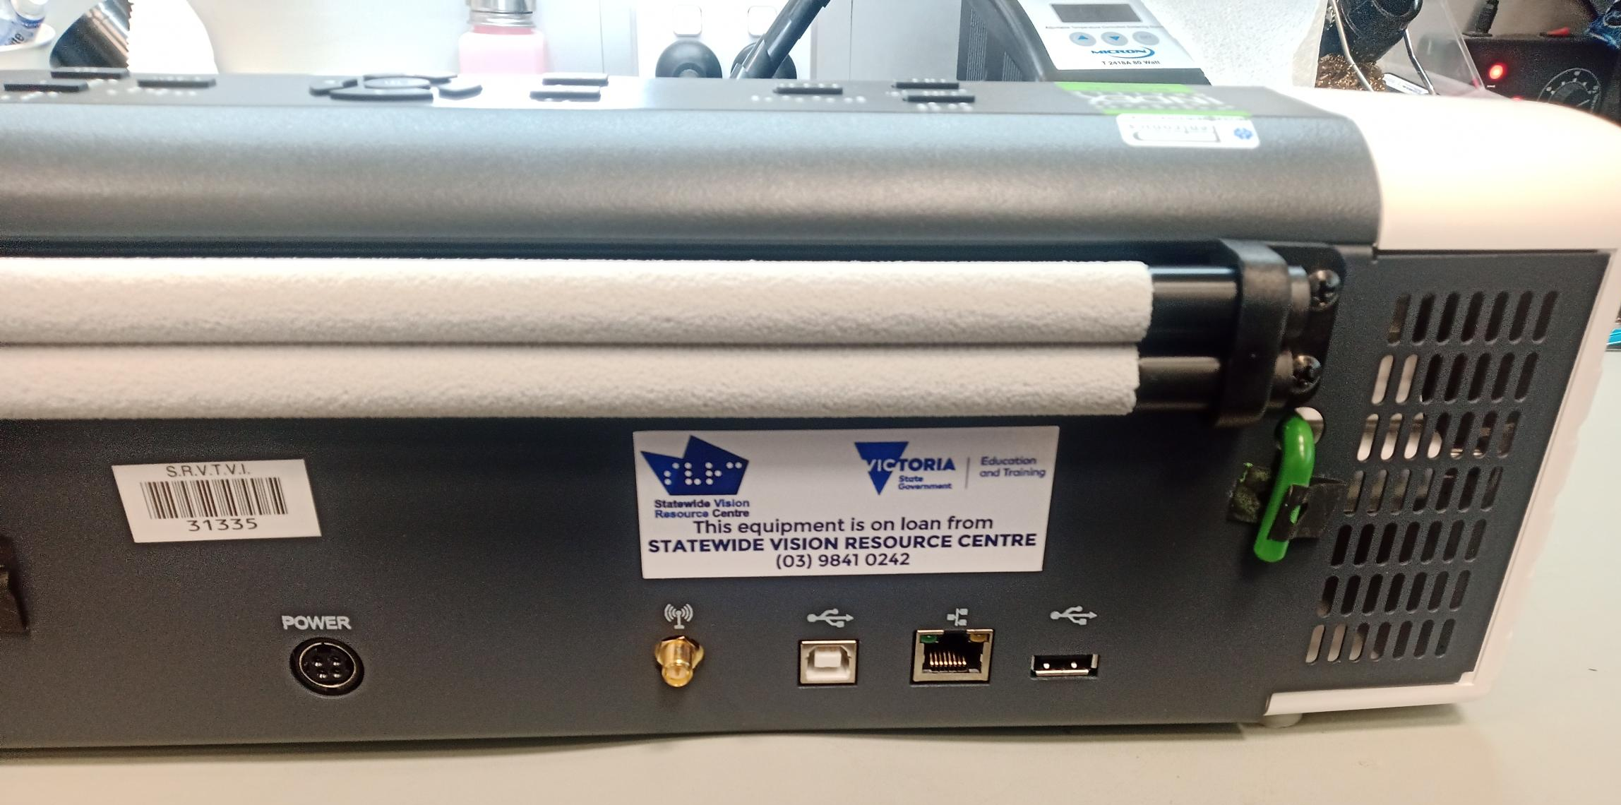
Also, notice the green transport locking pin to the far right. (This may not be present).
Once you have connected the power supply and USB to a computer, turn on the embosser my pressing the “On” button located at the top left of the front panel.
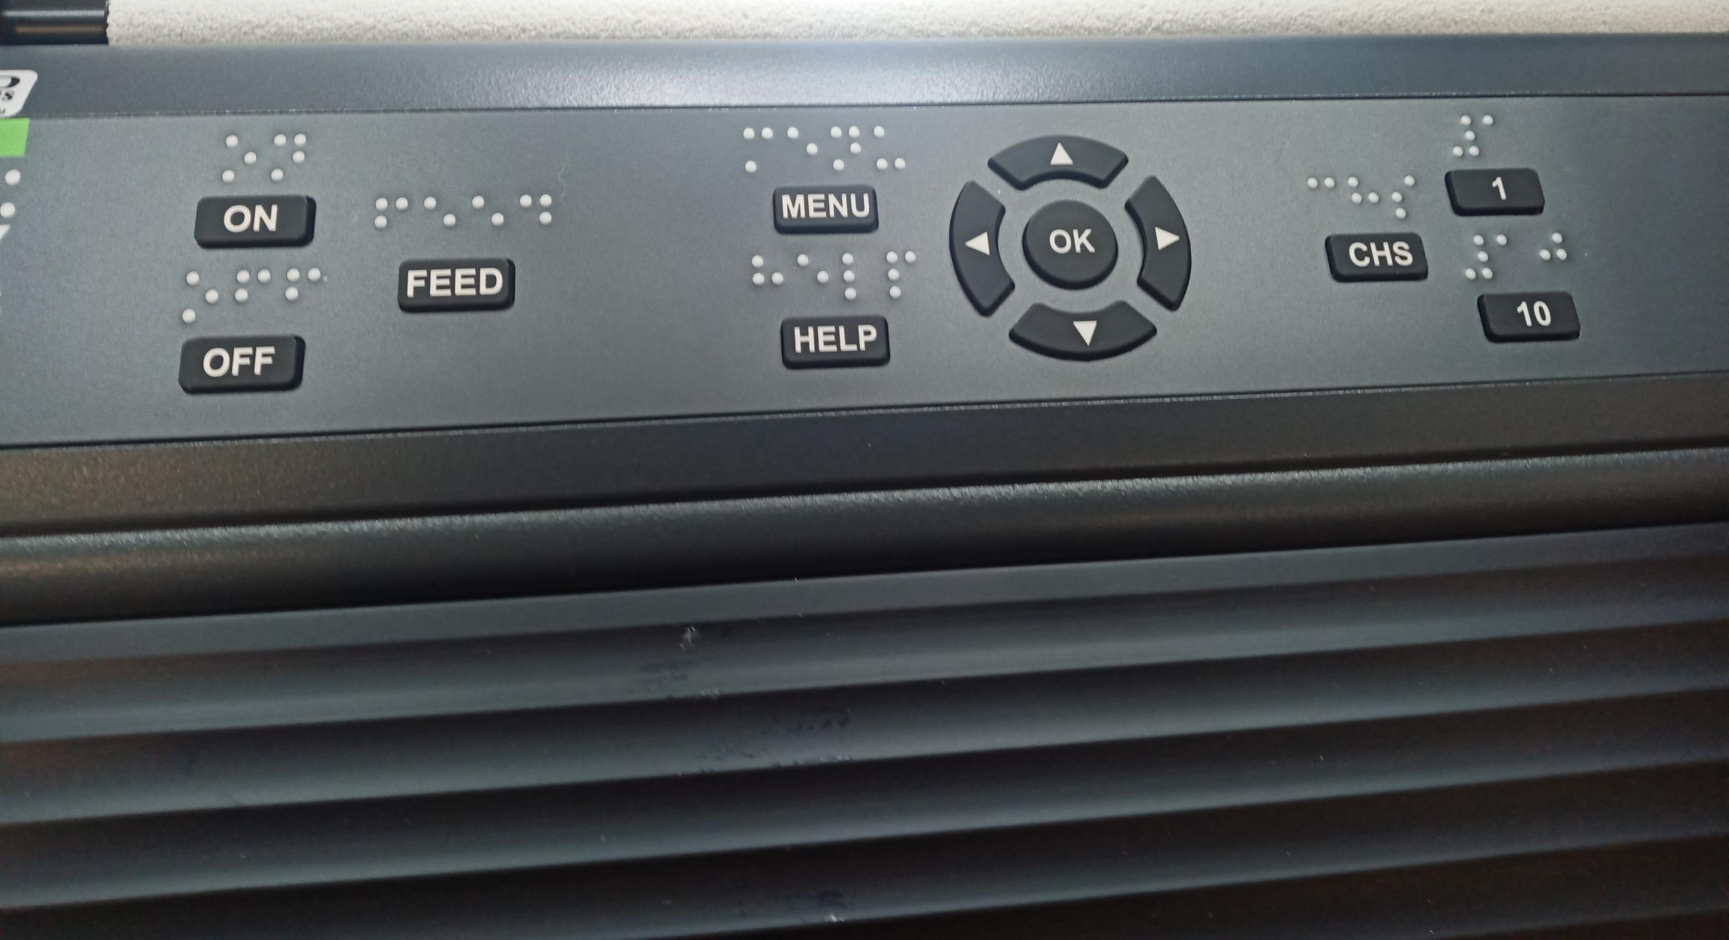
If the transport lock is installed the embosser will take to you through a voice guided transport lock removal wizard. Once the wizard is complete, the embosser will restart.
Now we are ready to install the printer drivers. If there is no thumb drive included in the box, the files can be downloaded from the Index Braille website or by contacting the SVRC Technology Library.
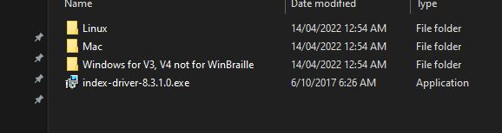
Once you have located the driver file, double click to install it.
Go to Windows Settings: click on the start menu and choose "PC Settings" or "Settings".
In the settings, click on the Devices icon and then select Printers and Scanners from the list on the left of the screen.
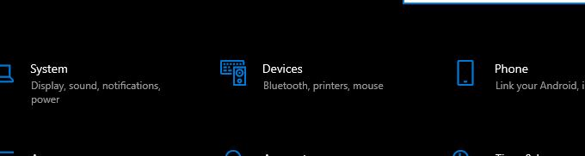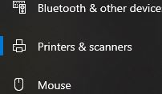
Click the Add a Printer or Scanner.
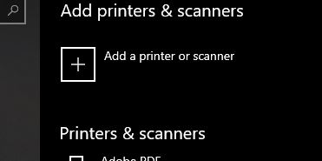

Click on "The printer isn’t listed".
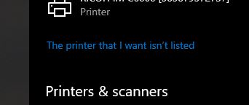
Once the add printer wizard appears, click the check box that says, "Add local printer or network printer with manual settings".
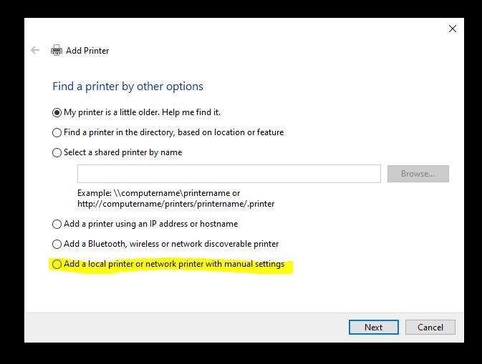
In the "use existing port" drop down list, select one of the virtual USB ports and then click next.
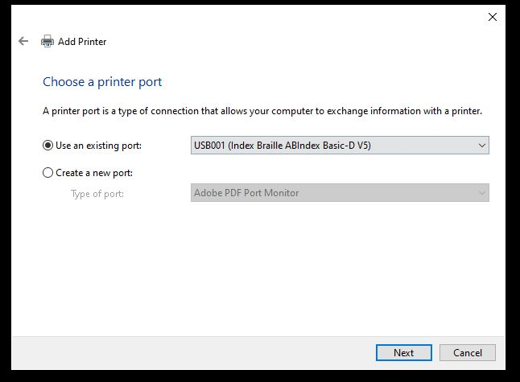

In the "Install the printer driver" window, under the manufacturer list select "Index Braille AB". Under Printers list select "Index Basic D V5". Click next.
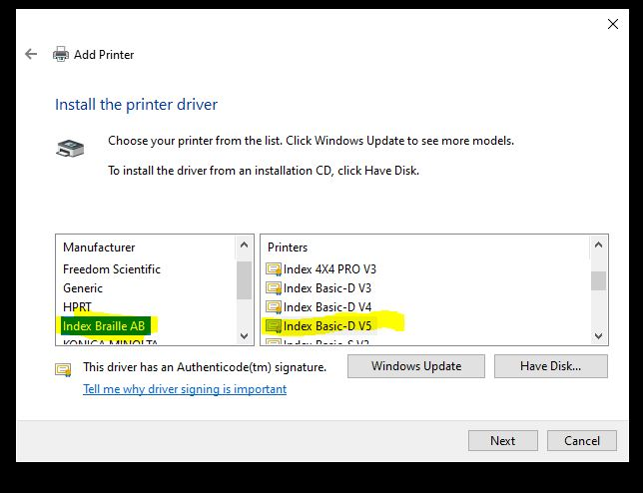
In the "Type a printer name" window, you can change the printer name if you like.
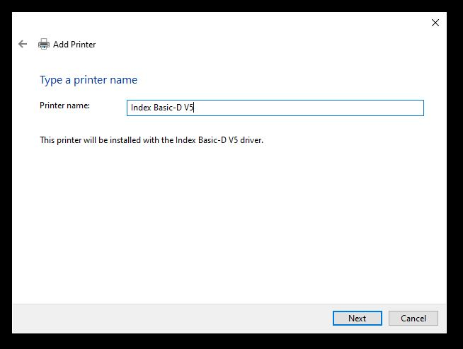

In the "Printer sharing" window, leave the printer sharing for this printer turned off. Click Next.
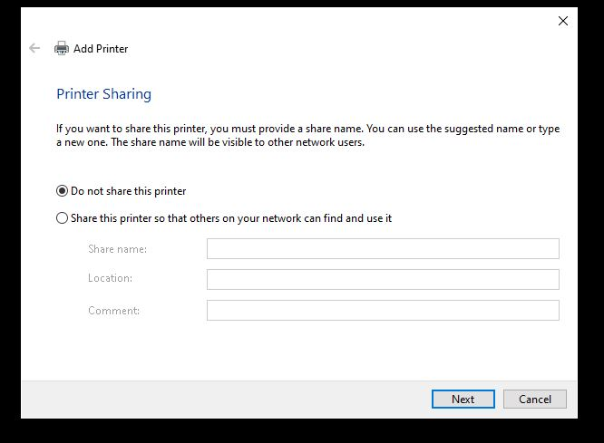
You can set the Embosser at the Default printer, and click the button to "Print a test page". Then click Finish.
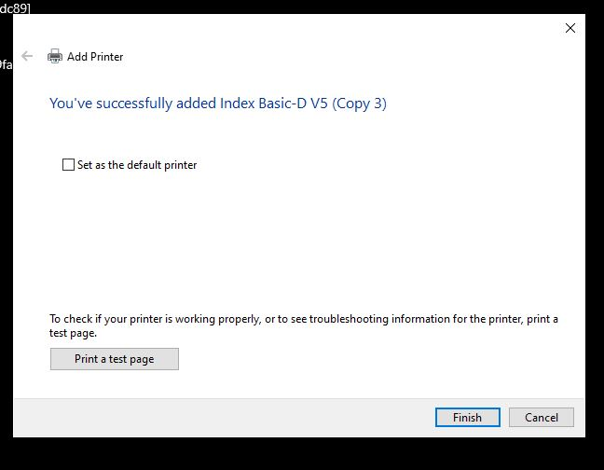
SVRC, March 2023

