Using a PIAF
The PIAF, or Pictures in a Flash, is a machine that can be used to make tactile drawings. You can draw or print onto special paper, called swell/capsule paper, then feed it through the PIAF to raise the image.
- Plug the cord into the PIAF and the other end into a power point.
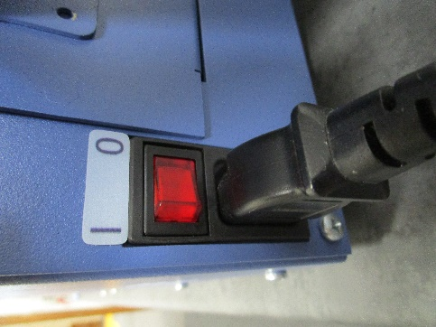
- Take the trays off each side and place them back on the same side, horizontally.
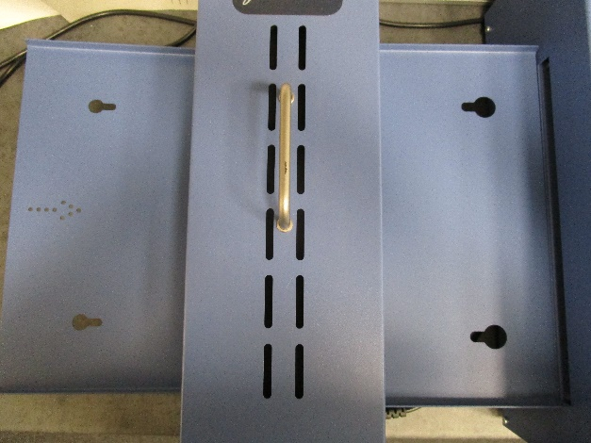
- Press on the left of the switch to turn on the PIAF
- Turn the heat dial up to high. Experiment with what the best heat level is for your paper. You may need to turn it down as you go if you're putting through a large volume of paper.
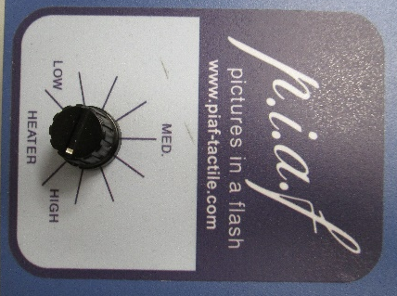
- Place the paper on the tray with arrow pointing towards the machine (arrow circled on picture above).
- A light will come on as the paper feeds through the machine and comes out the other side.
- Check the lines/dots to make sure they've raised sufficiently. If not, put it through again.

Paper
You can use A4 or A3 paper in the PIAF. There are a couple of difference brands of paper you can use with the PIAF
Magic Paper from Quantum RLV
Swell Touch Paper from Pentronics
From Quantum RLV
"To obtain the best tactile effect with Magic paper and PIAF, we recommend using a mono/ black only setting on your printer (laser or inkjet) and whiteboard markers rather than permanent marker pens. We have tested whiteboard marker pens from Staedtler, Artline, and J Burrows with good results."
SVRC Staff, December 2022

