Connecting a Camera with an iPad
Sony Cybershot Camera
- Download Imaging Edge Mobile App from the AppStore or through the Self Service App on the iPad.
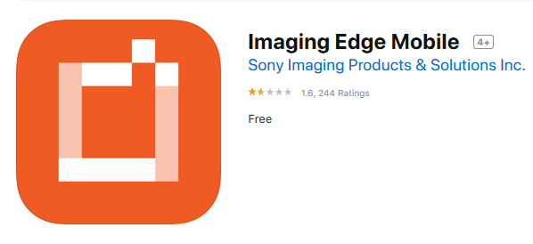
- Open the App
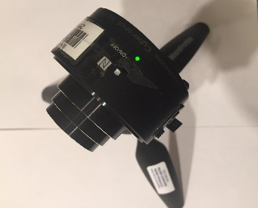
- Turn on the Camera
- To connect Camera to the iPad you have two options which are outlined below. This needs to be done only once at setup.
Option 1
  - On the iPad, go to Settings Wi-fi
  - Tap on 'Direct ………..' under the Choose a network section
  - You will be asked for a passcode. It can be found on the lid of the battery compartment.

Option 2
- Tap on 'Scan QR Code of the Camera. Tap OK
- Open the battery compartment and find the QR Code
- Put the QR Code in the middle of the camera and follow instructions on the App
You should now see the picture on the camera within in App

